Laboratory 3

QUESTION 1: In one or two sentences answer the following: What do you immediately notice about the boundary of the city of Los Angeles and the Neighborhood Councils layers? (you may have to uncheck and recheck the *Boundary_City_LA* layer to see the difference) What, if anything, do you immediately notice about the distribution (location) of the billboard points?

Most of the billboards are in Los Angeles, primarily in the downtown area. Furthermore, the Neighborhood Councils are located near the billboards. That means that Neighborhood Councils were formed were freeways were built in order to stop the transformation of their neighborhood. The distribution of the billboards follows the path of the freeways. They are more concentrated in the area of Downtown Los Angeles, were more people live.

QUESTION 2: Insert both the choropleth map .jpeg and the graduated symbols .jpeg into your report Word document and examine the differences. Describe the difference in how the data are visualized. In your opinion, does one map better convey the data and distribution of billboards? Why or why not?

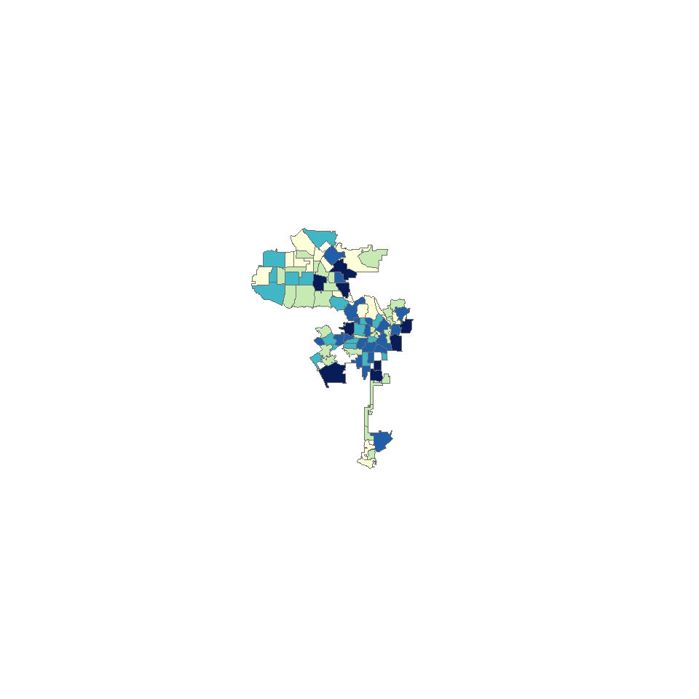

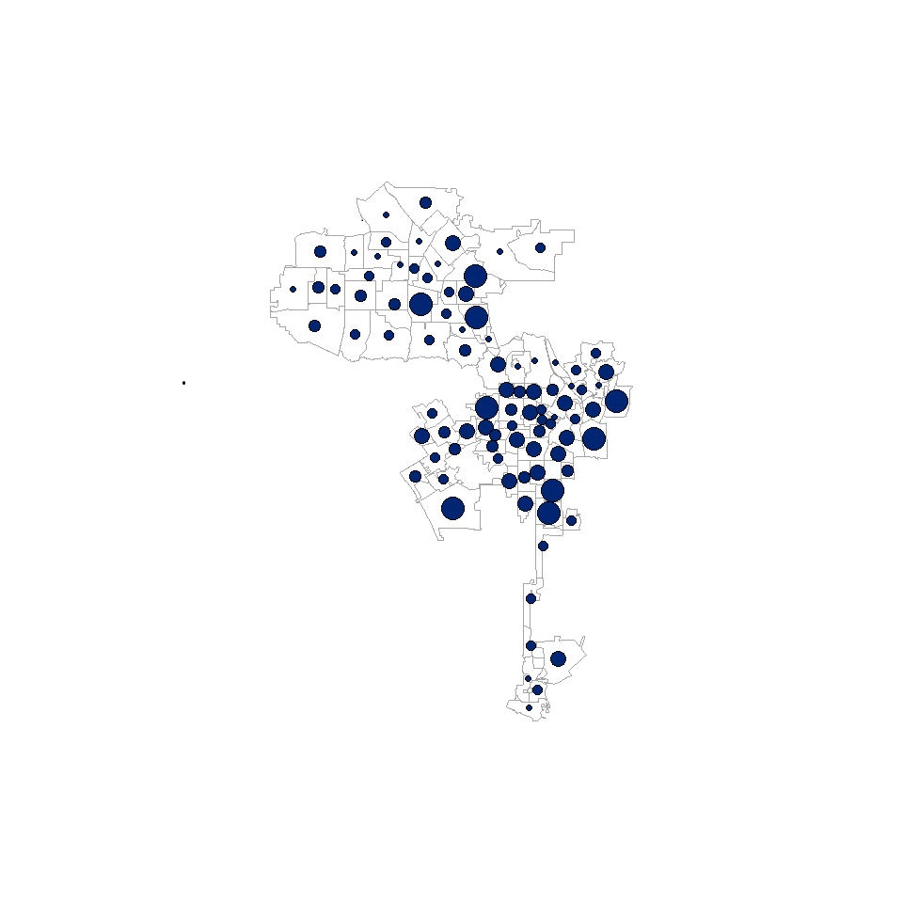

The difference in how data is visualized is that the choropleth is shows dark colors were the amount of billboards is larger. In the case of the gradsymbols, the size of the circle represents the amount of billboards in that area.

In my opinion, the gradsymbols image conveys the information and the distribution of the data better because it shows the amount of billboard and the distance between the areas. However, it is harder to appreciate those details in the choropleth map.

QUESTION 3: Insert the last .jpeg map of the graduated symbols over the choropleth of the population density to your report. Discuss the results and describe the difference in how the data are visualized. Again, does this map better convey the data and distribution of billboards? Why or why not?

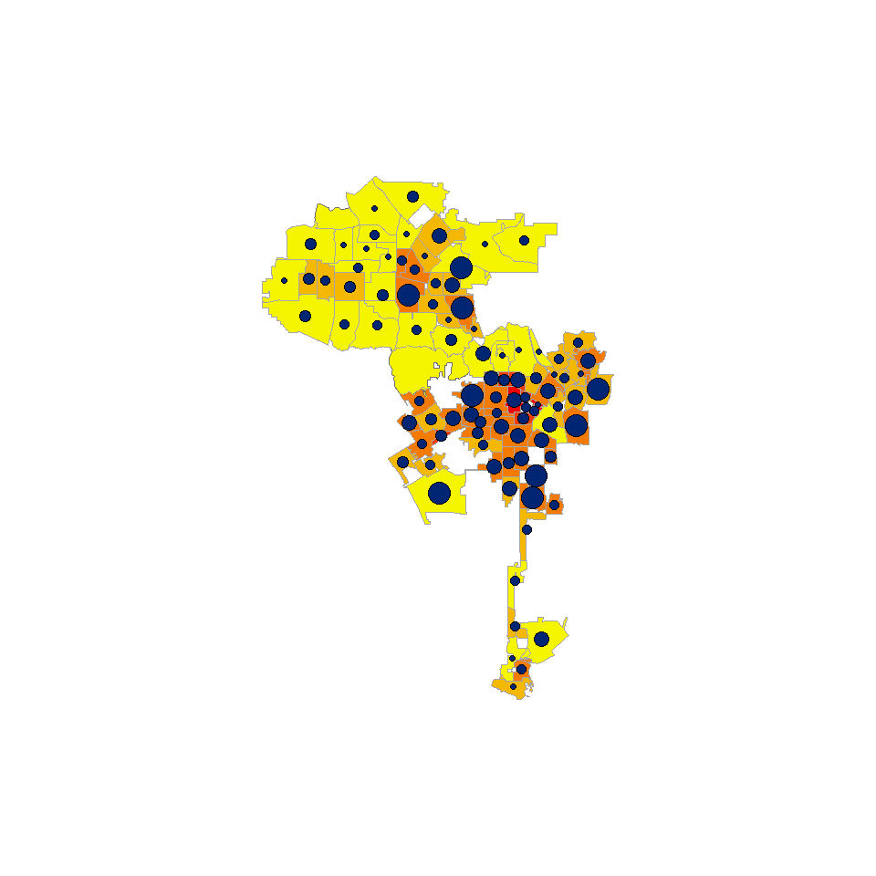

The data that has being visualized is different from the choropleth than the graduated symbols. Some of the areas are larger in size and have more quantity of billboards; however, they appear to have a light color due to low density. This gives misleading information and might result in an erroneous interpretation. This map shows that area plays a roll in the color scheme. Therefore, it is more accurate than the previous maps; however, there should be another method to expose the information where area does not affect the color of the map.

QUESTION 4: Can you see any relationship between the number of billboards in a neighborhood council and the population density? What does this tell you about the motives of outdoor advertisers in placing billboards?

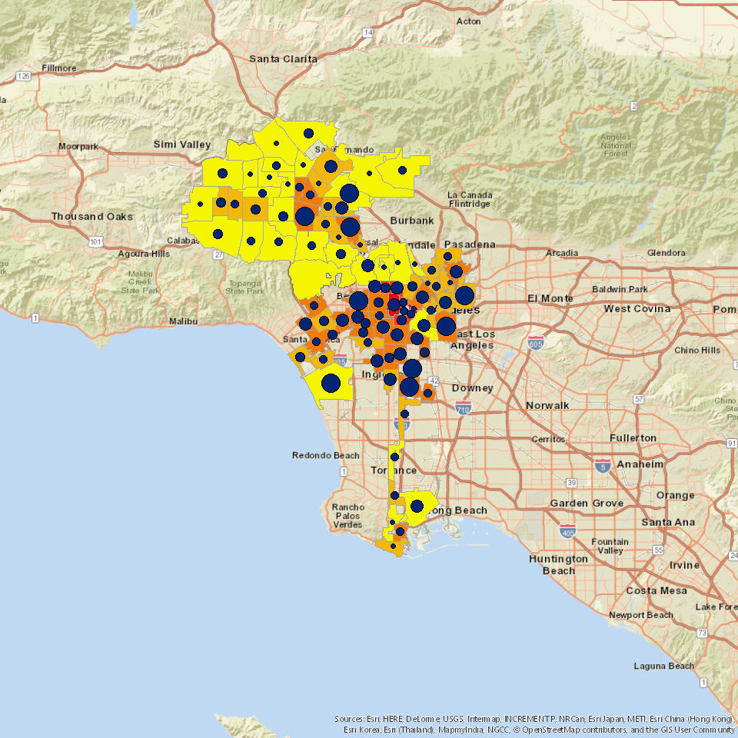

There is a relationship between the number of billboards in a neighborhood council and the population density. Usually, population density is greater near the areas close to the freeways. Furthermore, the number of billboards in a neighborhood council is large because they are next to the freeways as well. Finally, the neighborhood councils are formed, so their neighborhood is not changed. Therefore, the number of billboards in a neighborhood council is proportional to the population density. This is due to the fact that billboard owners want a significant amount of people to look at their advertisements.

QUESTION 5: Now, **zoom into** a neighborhood of Los Angeles that you are familiar with (if you are not very familiar with LA, you may zoom to the neighborhoods around USC, LAX, or downtown). Examine the distribution of billboards in that neighborhood. Does this accurately reflect what you have seen? Have you seen more or fewer billboards? You may want to uncheck the *LACITY-NEIGHBORHOOD_COUNCILS_w_POP* to see each billboard point. Export this local area as a .jpeg file named as “No_billboards_over_Pop_Local.jpg” and insert into your report.

I zoomed into Venice Beach. The map accurately reflects what I have seen. Venice Beach is a residential area. Therefore, there are not a significant amount of freeways there. Consequently, cars do not transit there very often and it is not profitable to put billboards in that area.

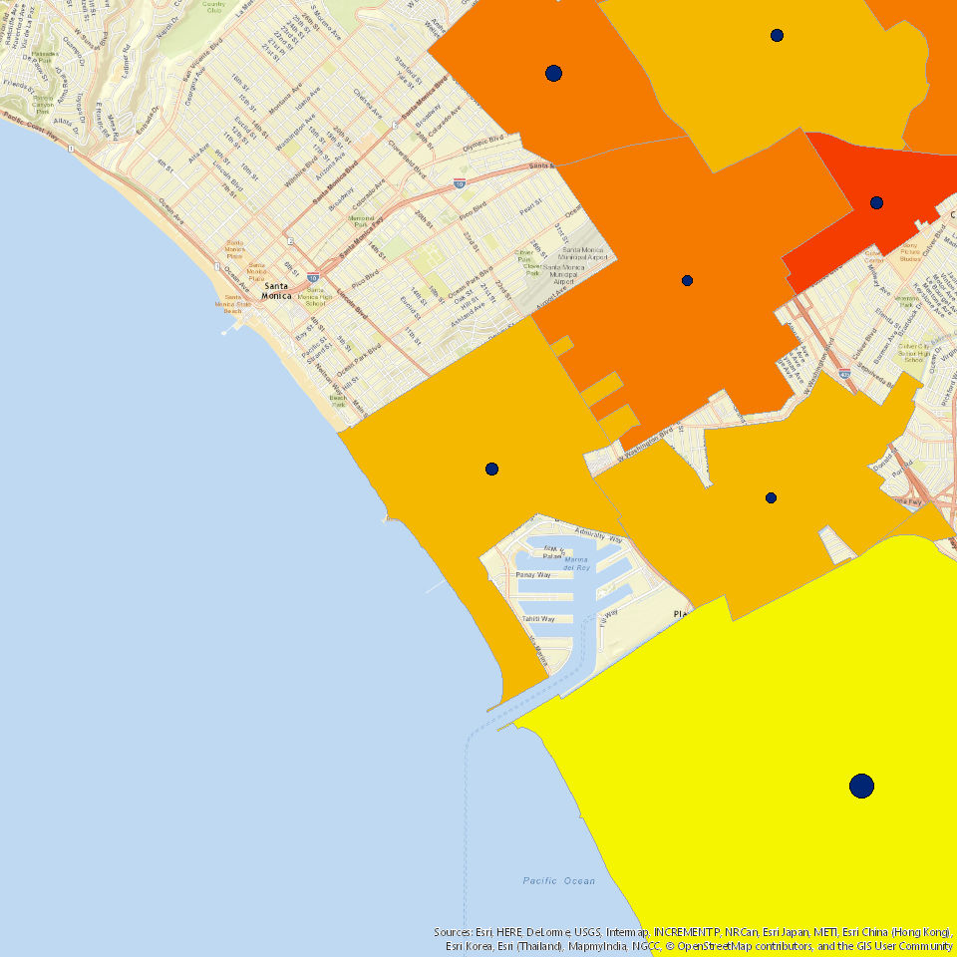

QUESTION 6: Now that you can clearly see the road networks, what can you tell about the spatial orientation of the billboards to the roads? Do you notice a difference between the Primary, Secondary, and Local road networks and the number of billboards present near each type of road? Why do you think billboards are placed in certain areas/near certain roads as opposed to others? Insert a screen capture (Snip) of your zoomed in location.

Most of the billboards are next to the freeway; however, all of the billboards are right next to a road, so that drivers can see it. Furthermore, billboards are placed in highly transited areas. More billboards are placed close to Primary road networks, then in Secondary road networks, and it seems like local road networks have less amount of billboards. Billboards are placed in certain areas near certain roads because those are the less residential and more transited areas. Therefore, more people are going to see the billboard.

